Milestone 1 – Team 13

Krish Patel

Nelig Fernando

Noah Zhou

Cole Bryant

Brayden Lingelbach

Introduction

* We are a small group of software developers looking to develop a membership management system for the Director’s Guild of America (DGA) union.
* We wish to develop a system that allows DGA members to apply for/manage their memberships to the DGA.
* We will also develop methods for production companies to apply for DGA sponsorships to recruit members within and DGA and have them receive benefits.

Project Vision Statement

For DGA members who need a method to manage their memberships with the DGA, the DGA Management System is a digital management system that streamlines the application process for members and production companies. Unlike traditional paper methods, the DGAMS will offer quicker application response times and connect companies with eligible members more efficiently. Our Product will allow members to receive their necessary benefits with ease while connecting them with production companies that seek to improve their working conditions.

Context Diagram

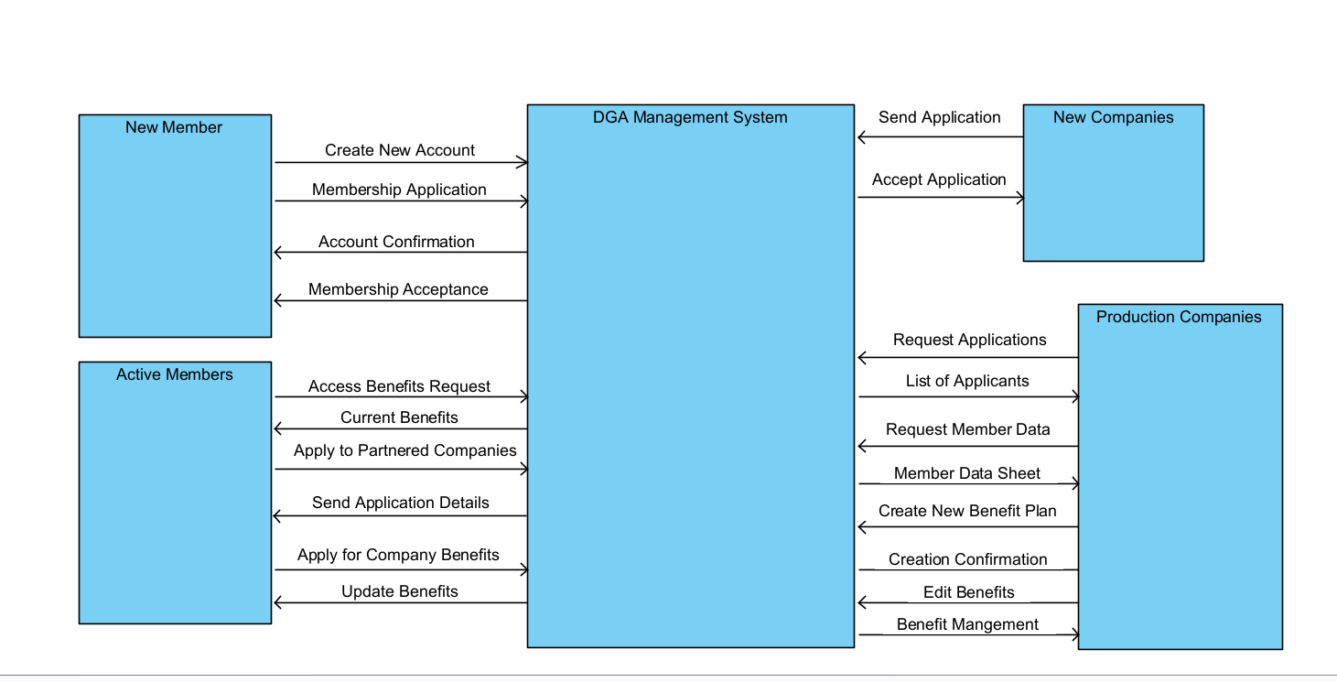

System Requests

* Project Sponsor:
  + The Directors Guild of America
* Business Need:
  + For Members
    - Streamlined method of application to the union.
    - Ease of management of one's membership.
    - Connections to eligible production companies to receive benefits.
  + For Production Companies
    - Ease of communication between members and production company.
    - Provide a list of eligible applicants for hire.
    - Provide members with necessary benefits.
* Business Requirements:
  + For Members
    - Create/apply for a membership account.
    - Check membership and eligibility status
    - Access/redeem benefits.
    - Access to DGA provided support.
    - Enroll in health and pension plans
  + For Production Companies
    - Apply to become a Signatory Company for DGA members.
    - Access a list of current members.
    - Network with current members and offer unionized positions
    - Access to necessary data.
* Business Values:
  + Tangible
    - Increased exchange of information between the companies and members.
    - Reduction in paperwork
      * Physical mail such as pension plan booklets and the DGA Plans Enrollment Questionnaire are no longer needed, they will be sent through email
      * Newsletters and informational letters will be sent by email
    - Increase in union members.
  + Intangible
    - Increased satisfaction among members.
    - Streamlined application process.
    - Better public perception from union sponsorships.
* Special Issues or Constraints:
  + The system should function digitally.
  + Members will access their information fully online.
  + The system should be scalable to accommodate an increase in members because of ease of access.
  + The system should be compatible with mobile devices as well as web browsers.

Product Roadmap

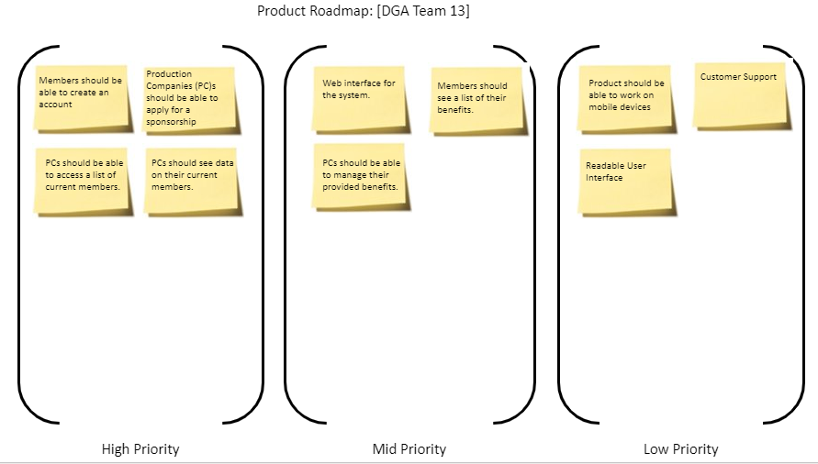

Product Backlog

|  |  |  |  |  |  |
| --- | --- | --- | --- | --- | --- |
| **Order** | **ID** | **Item** | **Type** | **Status** | **Estimate** |
| **1** | The members should be able to access benefits from sponsors. | | | | |
|  | 111 | As an applicant, I want to create an account so that I can apply for DGA membership so I may receive benefits. | Functional | Not Started | 3 |
|  | 112 | As a member of the DGA, I want to access my current benefits package so that I may know what I am entitled to as a member. | Functional | Not Started | 3 |
|  | 113 | As a member of the DGA, I want to be able to request new benefits from my sponsor so I may reserve the right to request benefits. | Functional | Not Started | 5 |
|  | 114 | As a member, I want to be able to transfer my benefits from one sponsor to another, so they remain when I am required to change companies. | Functional | Not Started | 8 |
|  | 115 | As a member, I want to be able to delete my account from the database, so I may choose to join another organization. | Functional | Not Started | 2 |
| **2** | The sponsor should be able to recruit and manage members. | | | | |
|  | 121 | As a sponsor, I want to create an account so we may begin to manage the benefits of our members. | Functional | Not Started | 3 |
|  | 122 | As a sponsor of the DGA, I want to view a list of my current members within my company so that I may view/manage these members. | Functional | Not Started | 2 |
|  | 123 | As a sponsor, I want to be able to recruit members within the DGA who have not been assigned a sponsor so we can expand our company. | Functional | Not Started | 5 |
|  | 124 | As a sponsor, I want the ability to remove members from our sponsorship in necessary instances so that we may have control. | Functional | Not Started | 2 |
| **3** | Users should be able to access profile information including their email, username, phone number, and other user specific data. | | | | |
|  | 131 | As a user of the software, I would like to be able to quickly pull up profile information the system has stored on me. | Accessibility | Not Started | 5 |
|  | 132 | As a user I would like to be able to send my profile information to the product company. | Accessibility | Not Started | 2 |
|  | 133 | As a user I would like to be able to request my information sent to other sponsors, and users. | Functional | Not Started | 2 |
| **4** | A user should have easy access to help within the system such as customer support, and support forums. | | | | |
|  | 141 | As a user of the system, I would like customer support so I may receive help with my account if necessary. | Accessibility | Not Started | 3 |
|  | 142 | As a user I would like to be able to easily communicate with other users about issues that I'm having within the system. | Accessibility | Not Started | 5 |
| **5** | Sponsors should be able to manage the benefits of their members. | | | | |
|  | 151 | As a sponsor, I want to be able to add benefits to our list of members so they may receive their benefits. | Functional | Not Started | 3 |
|  | 152 | As a sponsor, I want to be able to remove benefits from members in the necessary instances where those plans aren’t feasible. | Functional | Not Started | 3 |
|  | 153 | As a sponsor, I want to have the ability to respond to requests for new plans so my members can remain satisfied with their sponsorship. | Functional | Not Stated | 5 |
| 6 | The system’s web interface should be readable and accessible to all users. | | | | |
|  | 161 | As a user of the system, I want the website to have a readable UI, that way I can use the website more easily. | Accessibility | Not Started | 5 |
|  | 162 | As a user I would want quick response times from the system per my request | Performance | Not Started | 3 |
|  | 163 | As a sponsor, I want an intuitive management UI so that I can easily manage a large quantity of members. | Accessibility | Not Started | 8 |

Team Retrospective

* Planning
  + The team worked together to finish single tasks efficiently.
  + The team used designated meeting times.
  + The team worked together outside of designated meeting times to accomplish certain goals.
* Monitoring
  + The team communicated ideas to each other, and opinions on certain tasks efficiently.
  + Each member contributed to each portion of the project evenly
* Evaluation
  + The plan to implement the new system for the DGA was prepared in a well-constructed manner.
  + Each member needs to split the work more to decrease the time it takes to complete a task
* Plan of Action
  + Communicated designated meeting times so that there are no scheduling conflicts can be improved upon.
  + The DGA system needs to be further refined to provide the best serve for companies, and members.
  + Divide up the individual components of the system then work them together, so they connect and work together.